SCH4U – Chemical Bonding & Lewis Structures Handout

A. Chemical Bonds
What is a chemical bond?

There are 3 different types of molecules that can form as a result of chemical bonding: molecular elements, molecular compounds and ionic compounds.
Define the following:
1. Molecular Element:

Example(s):_______________________________

2. Molecular Compound

Example(s):_______________________________

3. Ionic Compound

Example(s): _______________________________

B. Ionic Bonds & Ionic Compounds

- Ionic Bond definition:

- Ionic compounds typically form between what type of elements?

- When many positively and negatively charged ions come together they can form large structures such as:

- A formula unit represents:

C. Covalent Bonding - Molecular Elements & Compounds

- Atoms in molecular elements and compounds are held together by:

- Covalent bond definition:

- Covalent bonds typically form between what type of elements:

- List some of the reasons that chemical bonds form:

- Valence electron definition:

- Use numbering and arrows to indicate the number of valence electrons in the elements of the columns of the periodic table below:

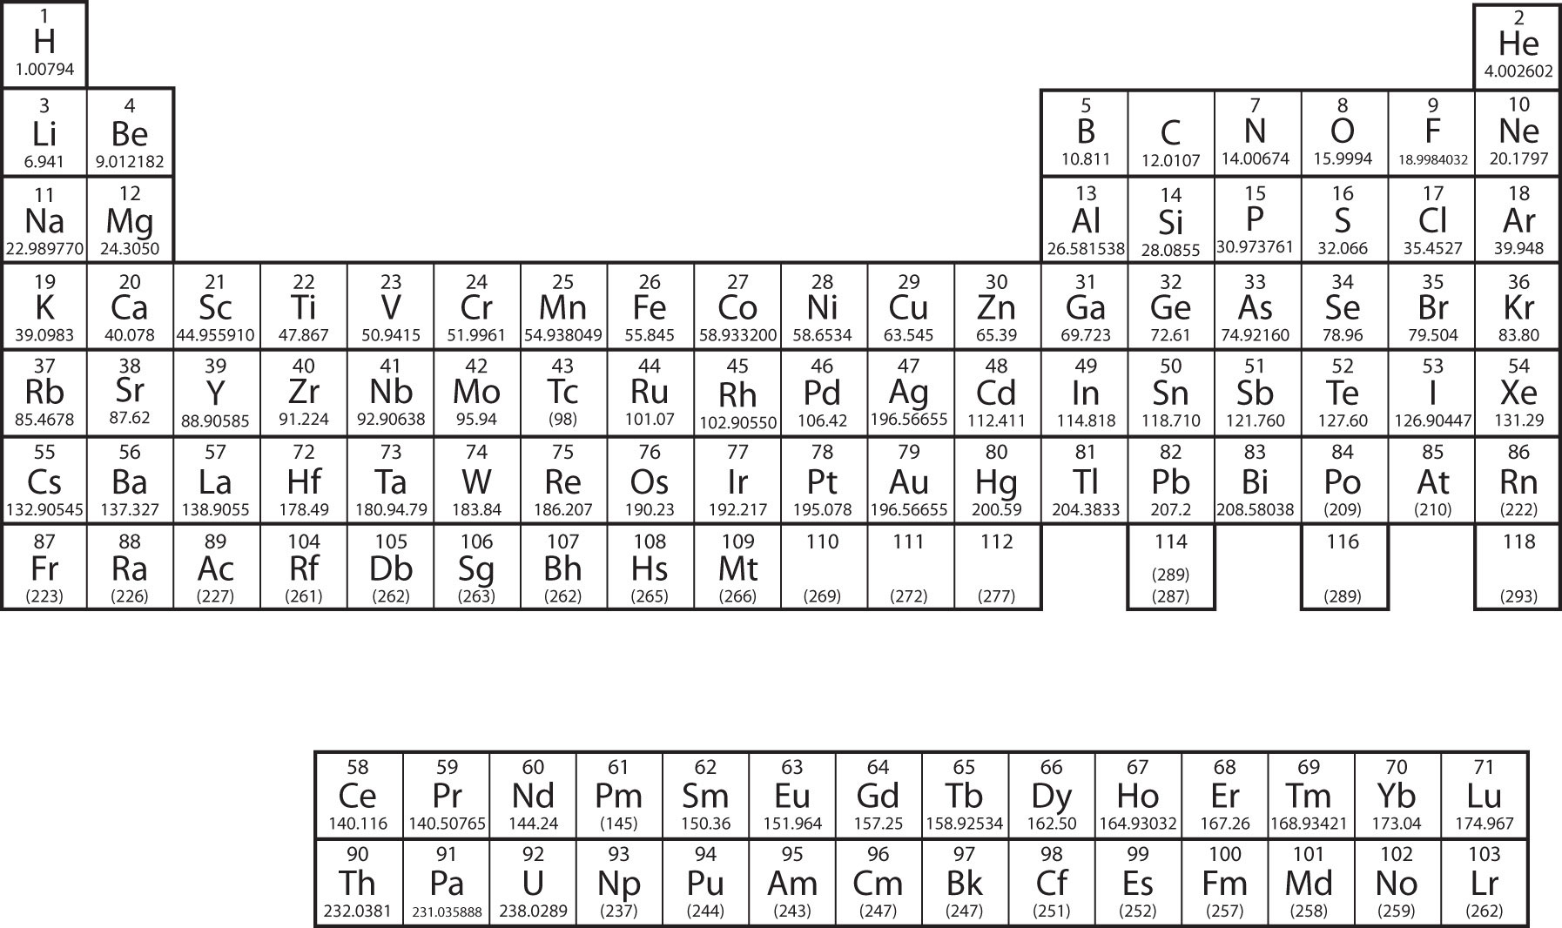

D. Lewis Theory of Bonding:

- Atoms and ions are most stable if they have:

- Electrons are most stable when they are:

- Atoms form chemical bonds to achieve:

- Full valence shells can be achieved by exchanging electrons between:

- Full valence shells can also be achieved by sharing electrons between:

- In Lewis structures, dots represent__________________ and lines represent_______________ in which pairs of electrons are__________________.

- Duet rule definition (H and He):

- Why does helium tend not to bond with other atoms?

**In a chemical bond, shared electrons “count” for both atoms that are sharing them in terms of filling the valence shell.**

- Octet rule definition:

- When atoms have 8 electrons in their valence shell, this is known as a:

- Draw the Lewis structure of F₂, indicating how each atom is able to form a stable octet by sharing electrons:

- Define bonding capacity:

What is the bonding capacity of the following atoms?:
- Carbon (C):
- Nitrogen (N):
- Oxygen (O):

F. Drawing Lewis Structures & Structural Formulas:

- Identify the central atom, which is the atom with the highest bonding capacity. Write the symbol for the central atom than arrange the symbols for the other atoms around it.
- Calculate the total number of valence electrons for the molecule. If the structure is a polyatomic ion, add 1 electron for each negative charge and subtract one electron for each positive charge.
- Place 1 pair of electrons between each pair of atoms to represent the bonding electron pairs of electrons. Each pair represents a single covalent bond.
- Place pairs of the remaining valence electrons as lone pairs on the surrounding atoms (not the central atom). Follow the duet rule for hydrogen and octet rule for all other atoms.
- Determine how many electrons are still available by subtracting the number of electrons you have used so far from the total number of valence electrons. Place any remaining electrons on the central atom in pairs.
- If the central atom does not have a full octet, move lone pairs from the surrounding atoms into a bonding position between those atoms and the central atom until all octets are complete.
- Check the finished structure. All atoms, except hydrogen should have a complete octet, counting lone pairs and shared electrons.

- Pairs of electrons that are not involved in bonding are called:_________________

Drawing Structural Formulas:
- To draw the structural formula of a molecule from a Lewis structure, remove the dots representing the lone pairs. Replace the dots representing the shared electrons with solid lines to represent covalent bonds. Use double or triple lines for double or triple bonds.

Draw the Lewis Structure and structural formula for H₂CO:

Draw the Lewis structure and structural formula for the following:
  - NBr₃

  - CF₄

  - C₂H₄

G. Drawing Lewis Structures for Polyatomic Ions:
The rules for drawing Lewis structures of polyatomic ions are the same as for molecular elements and compounds, except for the following:
- When calculating the total number of valence electrons for the molecule. If the structure is a polyatomic ion, add 1 electron for each negative charge and subtract one electron for each positive charge.
- When you have drawn the complete Lewis structure, or structural formula, place square brackets around the drawing and indicate the charge of the ion as a superscript.

Draw the Lewis structures and structural formulas for the following polyatomic ions:
- NO₃⁻

- PO₃³⁻

- CN⁻

- NO₂⁻

H. Exceptions to the octet rule:
- Carbon, Nitrogen, Oxygen and Fluorine atoms always obey the octet rule.
- There are some exceptions to the octet rule. Certain elements are able to form compounds in which the central atom has less than a full octet.
- Other elements are able to form compounds with more than a full octet.
Examples:
- Boron Trifluoride (BF₃) forms a molecule in which the boron atom has less than 8 valence electrons.
- Sulfur hexafluoride (SF₆) forms a molecule in which the sulfur atom has more than 8 valence electrons.

Draw the Lewis structures and structural formulas for BF₃ and SF₆

