SCH4U – Electronegativity & Polar Molecules

Describe the difference between a polar covalent bond and a non-polar covalent bond:

When do polar covalent bonds form?

Define electronegativity:

Atoms with __________ electronegativity values tend to pull shared electrons towards them.

Atoms with __________ electronegativity values give up their shared electrons easily.

Using arrows indicating increasing electronegativity values, show the trend for electronegativity on the periodic table:

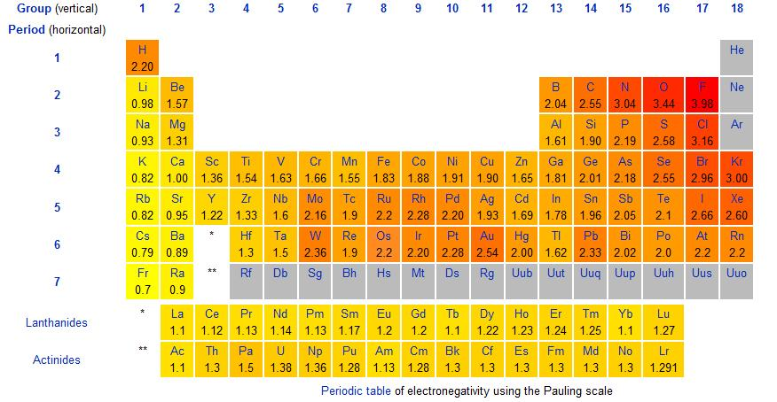

To determine the type of bond that forms between 2 atoms (ionic, polar covalent, non-polar covalent) you can calculate the______________________

Large ∆EN indicates what type of bonds:_______________ or ___________________
Small ∆EN indicates what type of bond:_____________

Complete the following table:

∆EN | Bond Type
< 0.5
0.5 - 1.7
> 1.7

Determine the ∆EN and classify the type of bond that forms between potassium (K) and bromine (Br):

Determine the ∆EN and classify the type of bond that forms between nitrogen (N) and hydrogen (H):

In bonds that have a polar character, the more electronegative atom becomes slightly__________________ and the atom with the lower electronegativity becomes slightly_____________________.

Define dipole:

Write the symbols for the negative end of a dipole and the positive end of a dipole:
When using an arrow to describe a dipole, the arrow points towards the _____________ end.

Molecular Polarity

Bonds can be polar or non-polar, entire molecules can also either be polar or non-polar.

Describe why water from a tap would be attracted to a balloon that was rubbed on someone’s head.

Draw the VSEPR predicted shape for H₂O and indicate the bond dipoles and net polarity of the molecule:

Non-polar molecules

Non-polar molecules have no _____________________

What affects the polarity of a molecule:

Describe how some molecules with bond dipoles can be non-polar:

Complete the following table:
Non-polar molecular structures with bond dipoles
Molecule Description | General Example | Specific Example
 | B-A-B
 |  | SO₃
Tetrahedral with 4 identical bonds

Determining the net polarity of a molecule:
- Draw the Lewis structure.
- Determine the predicted shape of the molecule using VSEPR.
- Identify the electronegativity of each atom in the molecule and determine the partial charges in the molecule.
- Draw bond dipoles and determine whether the molecule has a net dipole.

Predict the polarity of NH₃

Predict the polarity of CF₄

Predict the polarity of SF₂

