Name ________________________________ Date _________ Class __________

Practice with Organic Reactions
Directions: For each of the seven organic reactions below, use the word bank to fill in the missing blanks in the description as well as the reaction name. Then copy the appropriate example into the table as well. Reaction names are in bold.
Word Bank
Addition | Alcohol/ethanol | Base | Combustion | Double or triple
Esterification | Fermentation | monomers | Organic acid | Polymerization
Saponification | soap | Substitution | water
Examples:
CH₃CH₃ + Br₂ CH₃CH₂Br + HBr CH₂=CH₂ + H₂ CH₃CH₃
CH₃COOH + CH₃OH + CH₃COOCH₃ + H₂O NaOH + fat soap
C₆H₁₂O₆ CO₂ + CH₃CH₂OH C₃H₈ + 5O₂ 3CO₂ + 4H₂O
N (CH₂) (CH₂)n (n is a large number)
Reaction Name | Description (with example)
1. | Reacts sugar (carbohydrate) in presence of yeast and often produces _____________ and carbon dioxide  Ex:
2. | Combines many small molecules (similar or identical molecules called ___________ into one large molecule  Ex:
3. | Combines _____________________ and an alcohol  Ex:
4. | Combines fat and __________ to make a __________  Ex:
5. | Adds to hydrogen or halogen to an unsaturated hydrocarbon (unsaturated hydrocarbons have this kind of carbon bond: ___________________________  Ex:
6. | Replace a hydrogen on a saturated hydrocarbon with a halogen (halogens are found in Group ______ ( -- numbers are not in word bank!)  Ex:
7. | Combine with oxygen (burn), and produce carbon dioxide and ___________  Ex:

Practice Questions (Give reason/ show work for multiple choice!)
1. Which structural formula represents the products formed from the reaction of Cl₂ and C₂H₄?
- 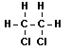  - 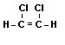 | - 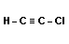  - 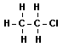
2. An alcohol and an organic acid are combined to form water and a compound with a pleasant odor. This reaction is an example of
- Saponification 2. esterification 3. polymerization 4. fermentation
3. Which equation represents a substitution reaction?
- CH₄ + 2O₂ → CO₂ + 2H₂O
- C₂H₄ + Br₂ → C₂H₄Br₂
- C₃H₆ + H₂ → C₃H₈
- C₄H₁₀ + Cl₂ → C₄H₉Cl + HCl
4. Given the equation: C₆H₁₂O₆ → 2C₂H₅OH + 2CO₂
The chemical process illustrated by this equation is
- fermentation 2. saponification 3. esterification 4. polymerization
5. Given the equation:
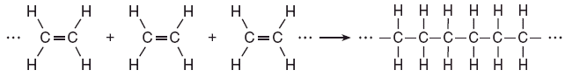
Which type of reaction is represented by this equation?
- Combustion 2. Esterification 3. Polymerization 4. substitution
6. Which reaction results in the production of soap?
- Esterification 2. Fermentation 3. Polymerization 4. saponification
7. Given the balanced equation below representing a reaction. This organic reaction is best classified as
CH₃CH₂CH₃ + Br₂ → CH₃CH₂CH₂Br + HBr
- an addition reaction
- an esterification reaction
- a polymerization reaction
- a substitution reaction
8. Given the balanced equation for an organic reaction between butane and chlorine that takes place at 300.°C and 101.3 kilopascals:
Identify the type of organic reaction shown in the chemical equation.
- addition 2. saponification 3. fermentation 4. substitution

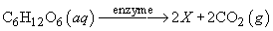
9. Given the balanced equation with an unknown compound represented by X:
Which compound is represented by X?
- CH₃OH(aq) 2. CH₂(OH)₄(aq) 3. CH₃CH₂OH(aq) 4. CH₂OHCH₂OH(aq)

10. Given the balanced equation for an organic reaction: C₂H₂ + 2Cl₂ → C₂H₂Cl₄
This reaction is best classified as
- addition 2. esterification 3. fermentation 4. substitution

11. X(g) + Cl₂(g) → XCl₂(g)
Which compound could be represented by X?
- CH₄ 2. C₂H₄ 3. C₃H₈ 4. C₄H₁₀

12. Given the reaction between 1-butene and chlorine gas: C₄H₈ + Cl₂ → C₄H₈Cl₂
Which type of chemical reaction is represented by this equation?
- Addition 2. Hydrogenation 3. Substitution 4. esterification
13. Given the equation:
To which class of organic compounds does product X belong?

1. alcohol 2. Ester 3. Ether 4. 4. alkane
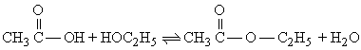
14. Given the reaction:
This reaction is an example of
- fermentation 2. saponification 3. hydrogenation 4. esterification

15 Given the equation: C₂H₆ + Cl₂ → C₂H₅Cl + HCl
This reaction is best described as
- addition involving a saturated hydrocarbon
- addition involving an unsaturated hydrocarbon
- substitution involving a saturated hydrocarbon
- substitution involving an unsaturated hydrocarbon

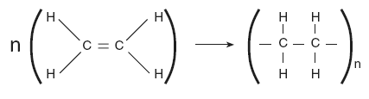
16. Which type of reaction is represented by the equation below?
Note: n and n are very large numbers equal to about 2000.

- Esterification 2. Fermentation 3. Saponification 4. polymerization

17. Which formula correctly represents the product of an addition reaction between ethene and chlorine?
- CH₂Cl₂ 2. CH₃Cl 3. C₂H₄Cl₂ 4. C₂H₃Cl

18. The reaction nC₂H₄ → (–C₂H₄–)_{n} is an example of
- Saponification 2. Esterification 3. Polymerization 4. fermentation

19. The process of joining many small molecules into larger molecules is called
- neutralization 2. polymerization 3. saponification 4. substitution

20. What type of reaction is CH₃CH₃ + Cl₂ → CH₃CH₂Cl + HCl
- addition 2. Substitution 3. Saponification 4. esterification

