Modeling Dynamic Equilibrium with Buttons – Teacher’s Version

Teacher’s Notes

- Groups should, ideally, be no larger than 4 students.
- Teacher’s can use different materials depending on what is available (instead of buttons you can use rocks, coins, etc.)
- Teacher should ensure that all students in each group take a turn at calculating/moving buttons.
- If time permits, discussion questions should be completed as part of the activity. If not, questions can be handed in at the start of next day’s class.
- Remind students that when doing discussion questions, they can still use the buttons and the piles to figure out the answer if they are having difficulty calculating the answer.

Activity Answer Key

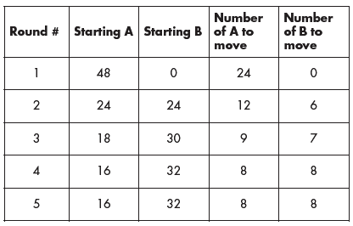

Answers to Questions
1. In the activity, the two piles equilibrate at 16 in pile A and 32 in pile B, Keq of 2. The second case gives the same results, but equilibrates in fewer rounds.
2. Rate constants a b = 0.3 per round and b a = 0.5 per round would give a 3/5 ratio for pile A and pile B. Final sizes would be pile A: 18 buttons, pile B: 30 buttons. Note that a round in the Activity is equivalent to a unit of time for a real rate constant.
3. The size of the initial population has no effect on Keq. The number of rounds changes slightly, because of the rounding effect.
4. The size of the rate constants, especially the forward rate when the reaction is starting with all of the material in pile A, determines the time to reach equilibrium. Some students may suggest a significantly smaller rate to test their hypothesis. If rates of 0.05 and 0.025 are substituted for the first series of rates, then the final equilibrium is the same, but the number of rounds increases by an order of magnitude.
5. If the 48 buttons are initially split between the two piles, or all of them are placed in pile B, the final equilibrium distribution remains the same.
6. This is not an accurate representation of dynamic equilibrium. In reality, movement would continue even after dynamic equilibrium was reached if this were a chemical reaction.
7. Students are usually surprised that a larger rate constant gives a smaller equilibrium concentration, and that the ratio of the rate constants matches the final Keq. For steps 1–9, the rate constant ratio of 0.5:0.25 gives a Keq of 2:1.

This activity was adapted from Martin Bartholow
Shawnee Mission North High School, Overland Park, KS 66202

Modeling Dynamic Equilibrium with Buttons

When there is a continuous exchange of items between one population and another, the system will reach dynamic equilibrium. In chemical reactions an equilibrium state can be recognized when the number of particles or concentration of each of the two populations (reactants and products) remains constant, but there is evidence that individual atoms or molecules are still exchanging between the two populations. This Activity explores factors that influence dynamic equilibrium, including how long it takes two populations to reach equilibrium, and the relative amounts of reactants and products present at equilibrium.

Activity

Materials: 48 buttons, 2 paper plates, pencil, paper, and calculator.

During each “round”, you will move buttons from pile A (reactants) to pile B (products) and from pile B to pile A. You can stop collecting data when the piles reach dynamic equilibrium. Since buttons cannot be divided, if you perform a calculation that results in a fraction of a coin, round the answer down.

1. Label a sheet of paper: Equilibrium for rate constant: a b = 1/2 per round and rate constant: b a = 1/4 per round. Construct a table with five column headings: Round #, Starting A, Starting B, Number of A to move, and Number of B to move.

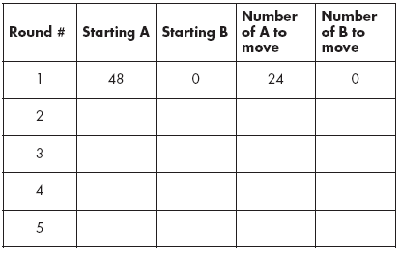

2. Begin with 48 buttons in pile A. For round one, calculate how many buttons to move from pile A to pile B using the appropriate rate constant from step 1. Record this number in the table under “Number of A to move”. (This calculation has already been completed for you, see chart above).
3. Determine the number of buttons to be moved from pile B to pile A using the appropriate rate constant from step 1. Calculate this number before moving any buttons from A to B; record it under “Number of B to move”.
4. Complete round one by moving the numbers of buttons you determined in steps 2 and 3 (and entered in columns 4 and 5) to the appropriate piles.
5. How many buttons are now in each pile? Begin the next round by recording the appropriate numbers of buttons under “Starting A” and “Starting B”.
6. Determine the number of buttons to move from A to B and B to A using the new starting numbers and appropriate rate constants. Record the numbers under “Number of A to move” and “Number of B to move”. Complete the round by moving the buttons.
7. Repeat steps 5 and 6 until the piles reach dynamic equilibrium.
8. Calculate the equilibrium constant, Keq. The equilibrium constant measures how far a reaction proceeds before reaching equilibrium. For this Activity, this can be calculated using: Keq = final # of buttons in pile B/final # of buttons in pile A.
9. Rounds can be performed mathematically without buttons. Based on the rate constants and starting numbers above, write two equations that would allow you to calculate the numbers in piles A and B for each round.

Questions

1. Predict the effect on Keq if the rate constants change to: a b = 2/3 per round and b a = 1/3 per round. Test your prediction. How does this compare to Keq and the number of rounds needed to reach equilibrium using the rates in step 1?
2. What is the relationship between Keq and the rate constants? Calculate the final size of the piles for a b = 0.3 per round and b a = 0.5 per round, with 48 buttons.
3. What effect does the size of the initial population have on Keq and the number of rounds needed to reach equilibrium? Using the rate constants from step 1, try an initial population of 480.
4. The number of rounds to reach equilibrium in this Activity is very small. Predict what determines the number of rounds needed to reach equilibrium. Carry out the necessary procedure to test your prediction.
5. Use the rate constants from Activity step 1 to predict the final sizes of the piles when starting with: (1) 24 buttons in pile A and 24 buttons in pile B, and (2) 48 buttons in pile B. Test your prediction.
6. In this activity, the dynamic part of the equilibrium occurs only when you are actually moving the buttons, is this an accurate representation of dynamic equilibrium? Why or why not?
7. Does a larger rate constant give a larger or smaller equilibrium concentration?

