SCH4U – Naming Alkanes

Naming simple alkanes

For all organic compounds there is a basic naming system using prefixes and suffixes.
For simple hydrocarbons, the prefix indicates the number of _______________atoms and the suffix indicates the type (alkane, alkene, alkyne)

Example methane: meth- = one carbon; -ane = alkane.

The chart below indicates the names of the first 10 simple alkanes. You are expected to know these.
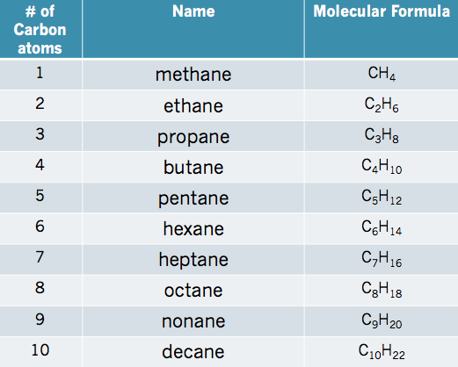
Memory tools can help you remember the names:
Monkeys Eat Peeled Bananas, Pandas Hear Happy Otters Napping Daily

Name the alkane shown below:
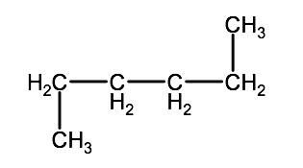
Name:_____________________________________

Alkyl Groups:

If an organic compound has a hydrocarbon group that branches off from it, the branched group is called an alkyl group. Naming alkyl group follows the same rules as for simple alkanes, but the suffix changes to –yl.

For example a branch that contains an alkyl group with 1 carbon would be identified as methyl

A alkyl group that contains 3 carbons would be called_________________

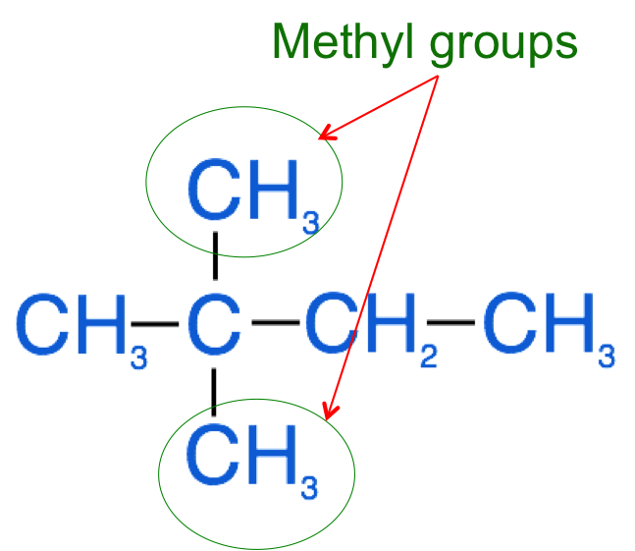

Naming Complex Alkanes

When naming organic compounds you must identify:
- the longest continuous carbon chain. This is known as the parent chain and will form the root name of the molecule.
- the number of carbons in each branched alkyl group.
- the carbon in the parent chain that a branched alkyl group branches from.

Steps for naming complex alkanes:
- Identify the parent chain. This is the longest continuous carbon chain within the molecule.
- Identify all of the branched groups (also known as the substituent groups) attached to the parent chain.
- Number the parent chain's carbons from the end so that the substituents are attached to the lowest possible numbers.
- If there is more than one of the same substituent type, use a prefix to indicate the total number of that substituent (2 = di-, 3 = tri-, 4 = tetra-) and a number to indicate the location of each substituent.
- list the names of the substituents in alphabetical order, ignoring the prefixes and add the root name at the end.

Use the step-by-step method above to name the molecule below:

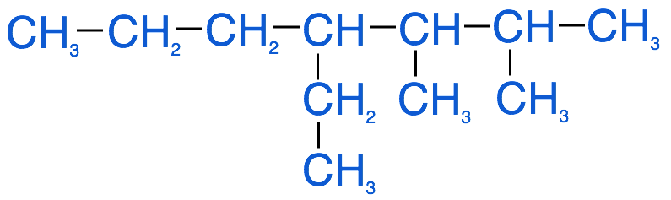

1. Parent chain name___________________
2. Branched groups: 2x_____________________, 1x________________,
3. Number the carbons in the molecule above.
4. Prefix for methyl groups___________
5. Name of molecule_______________________________

Name the following molecules:
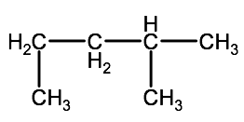

Name__________________________________

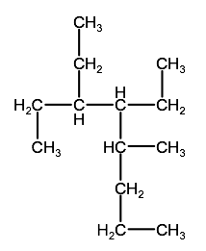
Name:________________________________

