Rates of Reaction Group Activity Teachers Resources
Teacher Instructions:
This is a group activity and groups of three or four students are ideal. Each group should have one set of the information cards which is dealt out between the members of the group. The cards are labelled with which part of the activity they are for; they can all be dealt out at the start and the students told to refer just to the cards for the part of the activity they are working on. They should not ‘lay their cards out on the table’ unless they are stuck.
Cards which have an asterisk (*) can be held back by the teacher initially and given to the students when or if they need help.
The groups could produce one set of written answers which could be reviewed in the light of the Discussion of answers sheet by another group (with instructions to be positive in their comments).
If you want to reuse the information cards it is helpful to reproduce them on different coloured card or paper.

Student Instructions

You have been given some information cards. You can share this information with other members of the group (ie tell them about it), although you should not show other people in your group your cards. You will need to use the information cards for parts 1, 2 and 4. The cards are labelled according to which part of the activity they relate to.
Use the information in the cards to help explain why Kc for a single step reaction A + B C + D is equal to [C][D]/[A][B].

Cards:
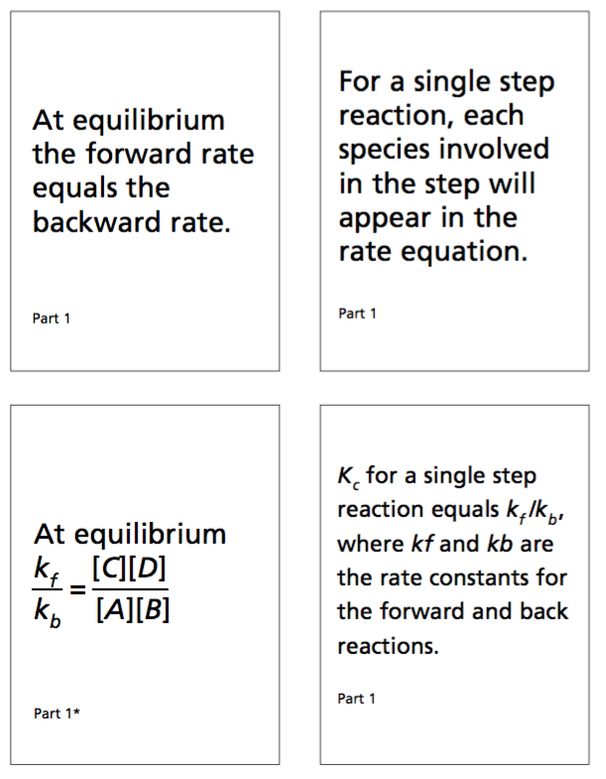

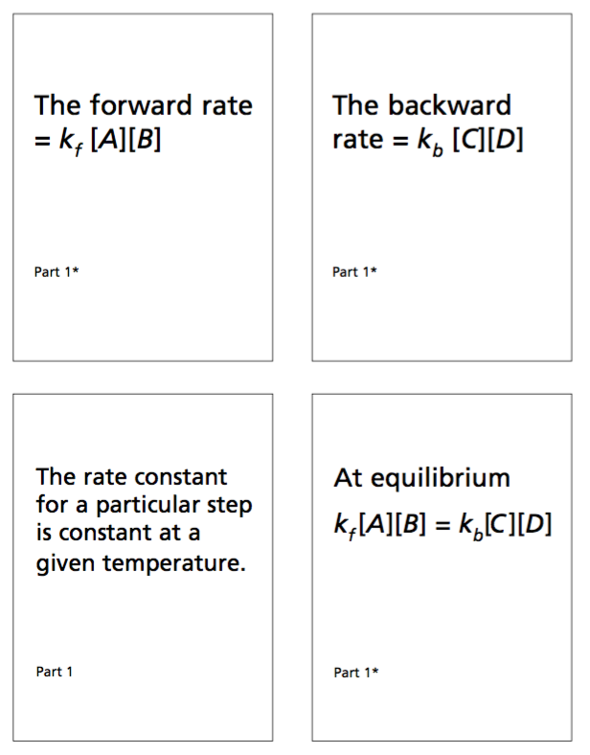

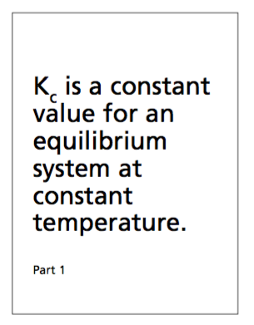

Solution
